Construct | Positive Behavioural Examples | Negative Behavioural Examples
Shape  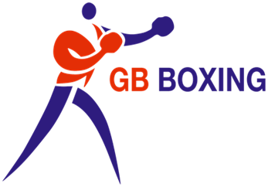 | - Ball of back foot  - Rear foot offset  - Weight balanced between feet  - Trunk side on – front shoulder closest to opponent  - Chin down, hands high, elbows in  - Return to this position when not punching | - Flat footed  - Back foot in line with front foot  - Weight unbalanced  - Square on to opponent  - Low hands in punching range, chin high, elbows wide

Footwork  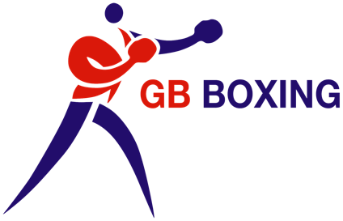 | - Is able to defend and attack with their feet  - Is able to move in all directions without breaking your base  - Is able to punch and defend at anytime when ready | - Brings feet together  - Will have flat feet  - Walks forward square on  - Brings feet off the ground when punching  - Poor base

Defence  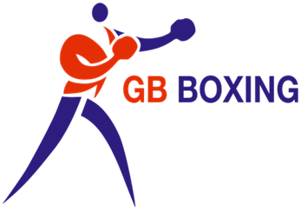 | - Is able to defend and attack with their feet  - Is able to move in all directions without breaking your base  - Is able to punch and defend at anytime when ready | - Reach out with hands  - Push shots down  - Is slow to respond to shots  - Make poor choices when defending  - Moves to far away and rushes  - Panics when defending shots

Punch Quality | - Is in range when throws shots  - Is accurate with their shots  - Shots are landed with power and speed  - Can throw a variety of punches and combinations of punches  - Lands with knuckle part of glove | - Is out of range when throws  - Slaps  - Doesn’t land with knuckle part of gloves  - Has no power or speed on punches  - Has their shots telegraphed

Flow | - Gets into a rhythm quickly  - Lets their punches go  - Controls the tempo of the bout  - Is economical through the bout – punches when ready  - Effortless footwork  - Breathes comfortably | - Stops and starts  - Is flat footed  - Boxes at one pace  - Has the pace of the bout dictated to them  - Rushes & leaves feet behind

Construct | Positive Behavioural Examples | Negative Behavioural Examples
Tactical Intelligence | - Follows brief where appropriate  - Is able to switch to plan ‘B’  - Can work out situation and adapt | - Blames others for tactical mistakes  - Doesn’t have a planB  - Is unable to stick to tactics – deviates from plan  - Can’t explain why they conceded shots

Ability to read opponent | - Can read opponent quickly  - Maximises opportunities when available  - Has positive body language  - Notices and articulates subtle changes in opponent | - Stays one paced  - Has negative body language  - Can’t identify opponents cues

Ring Awareness | - Is aware of where the judges are to catch their eye  - Moves in all directions  - Always has spaces behind them  - Dictates where their opponent is in the ring | - Finds themselves on the ropes consistently  - Allows their opponent to dictate where they are in the ring  - Continuously moves one way

Tempo | - Always looks to start at the right pace  - Controls the speed of the bout  - Paces the rounds well  - Follows a sustained pace with a strong finish throughout rounds | - Starts too fast and blows up  - Starts too slowly  - Has their tempo controlled by opponent  - Loses the last 30 seconds of each round

